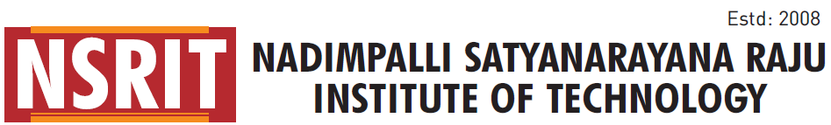
(Approved by AICTE, New Delhi& Affiliated to JNTU, Kakinada)
SONTYAM, ANANDAPURAM, Visakhapatnam-531173
NSRIT/CIR/staff/2017-18/008 Date: 13-06-2017
CIRCULAR

Sub : NAAC Inspection visit our college – Reg.

We are aware of that, NAAC members will visit to the Institute for conduct the inspection issue of grading.
Regarding, this year we are expecting the NAAC member may visit to our college. In this connection, all faculty and staff are requested to attend the college without taken any type leave and further, update all documents and records and should be ready with proper display at the time of NAAC.
HODs are requested to take care of your department and ensure all the staff (Teaching & Non Teaching) should attend to the college without fail.
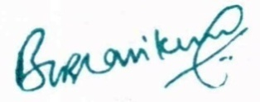

PRINCIPAL

Copy to:
1. Secretary – for kind information
2. Vice Principal – Academics: for information
3. Assistant Principal – Admn.: for information
4. Vice Principal – Polytechnic: for information
5. All HODs – CE/EEE/ME/ECE/CSE/S&H/MBA/Diploma: for information and circulate to staff concern.
6. A.O.: for information

