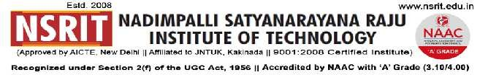
SONTYAM, ANANDAPURAM, Visakhapatnam-531173
No: NSRIT/CIRCULAR /2019-20/100 Date: 02-12-2019

CIRCULAR

The following committee is constituted to review and verify the below mentioned check list in Board Room today at 3.00 pm. In this regard all the HODs along with one Senior Faculty present for mock inspection. The committee has to verify and to submit compliance report to the undersigned.

MEMBERS :

Dr.G.Satyanarayana, Professor,CSE.
Dr.K.Ravi Kumar, Assoc Professor, ECE.
Dr.R.S.R.Krishnam Naidu, Assoc Professor, EEE
Mrs.A.Madhavi Latha, Asst Professor, MBA.

CHECK LIST :

1) Faculty list for AY : 2016-17, 2017-18, 2018-19, 2019-20.
2) Faculty personal files (updated Resume, Appointment order/Office order (with pay band), Joining report, experience certificates, qualification certificates, Pay Slips, Individual workload slip, copies of paper publications, achievement certificates, ratification letter, Aadhar & Pan photocopies).
3) Lab master.
4) List of class rooms and laboratories with plinth areas.
5) Student attendance registers - UG & PG (present & previous semester).
6) PG lab log books, time tables, lab occupancy.

PRINCIPAL

Copy to:
- Secretary : for kind information
- Correspondent : for information
- A.O: for information
4. All HODs–CE/EEE/ME/ECE/CSE/S&H/MBA/DIP/OIE/LIB/PD/ACC/HOSTEL(B/G): for information.
- Copy to above members : for information
CE | EEE | ME | ECE | CSE | S&H | MBA | DIP

