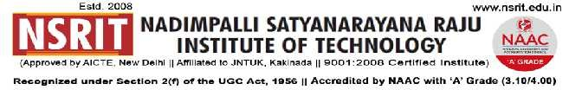
SONTYAM, ANANDAPURAM, Visakhapatnam-531173
No: NSRIT/CIRCULAR /2019-20/101 Date: 07-12-2019

CIRCULAR

It is hereby informed to all the HODs that, the following list of students Readmitted in II semester for the academic year 2019-20.

Year | Roll No. | Branch | Name
II-II | 17NU1A0206 | EEE | S.JAYA KRISHNA
II-II | 17NU1A0504 | CSE | B.PRASANTH UMAR

PRINCIPAL

Copy to:
- Secretary : for kind information
- Correspondent : for information
- A.O: for information
4. All HODs–CE/EEE/ME/ECE/CSE/OIE/LIB/ACC/ for information.
5. Office for information.

CE | EEE | ME | ECE | CSE | S&H | MBA | DIP | OIE | Library | Accounts

