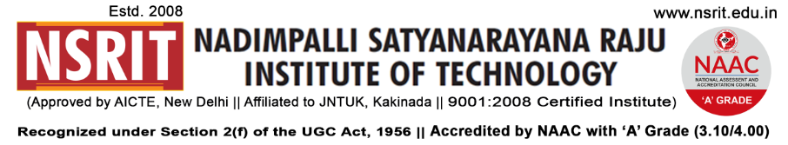
SONTYAM, ANANDAPURAM, Visakhapatnam-531173
NSRIT /CIRCULAR/2019-20/103 Date: 17-12-2019

CIRCULAR

The following committees with members are constituted to audit the academic labs of the departments and required to submit the compliance report on findings to the undersigned by 17/12/2019.
S. No. | Name of the Committee Member(s) | Departments to be inspected
1. | Dr G Satyanarayana, Professor, CSE  Mr M Siva, Asst. Professor, ME | EEE , ECE
2. | Sri N Sai Varma, Assoc. Prof., S&H  Mr A Yellaji, Asst. Prof., EEE | CSE, MECH, MBA
3. | Dr K Ravi Kumar, Asst. Prof.,  Dr RSR Krishnam Naidu, Assoc. Prof., | CE, S&H, Diploma

PRINCIPAL i/c
Copy to
- Secretary: for kind information.
- Correspondent: for kind information.
- A.O for information
- All HODs – CE/EEE/ME/ECE/CSE/S&H/MBA/DIP/OIE/LIB/PD: for information and circulation among all the staff members.

CE | EEE | ME | ECE | CSE | S&H | MBA | DIP | OIE | LIB | PD

