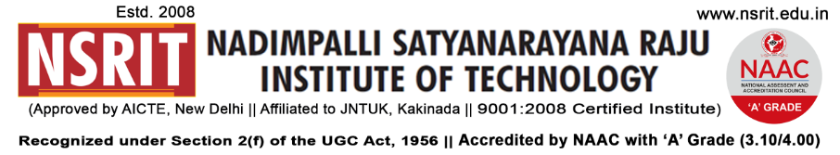
SONTYAM, ANANDAPURAM, Visakhapatnam-531173
NSRIT /CIRCULAR/2019-20/106 Date: 31-12-2019

CIRCULAR

The college observes holiday tomorrow 01-01-2020 (Wednesday) for all students on account of “New Year”.

“WISH YOU ALL A VERY HAPPY NEW YEAR 2020”
MAY THIS NEW YEAR BRING HAPPINESS, NEW GOALS, NEW ACHIEVEMENTS AND A LOT OF INSPIRATIONS IN YOUR LIFE

PRINCIPAL
Copy to
- Secretary: for kind information.
- Correspondent: for kind information.
- A.O for information
- All HODs – CE/EEE/ME/ECE/CSE/S&H/MBA/DIP/OIE/LIB/PD: for information and circulation among all the students.
---------------------------------------------------------------------------------------------------------------------
Copy to: CTO : He is requested not to operate busses on 01-01-2020. All the services may be operated as usual from 02-01-2020.
---------------------------------------------------------------------------------------------------------------------
CE | EEE | ME | ECE | CSE | S&H | MBA | DIP | OIE | LIB | PD

Class Rooms
Section | Staff | Student | Section | Staff | Student | Section | Staff | Student | Section | Staff | Student
I CSE-A |  |  | II CE |  |  | II ME-A |  |  | II ECE
I CSE-B |  |  | III CE |  |  | II ME-B |  |  | III ECE
I ECE-A |  |  | IV CE |  |  | III ME-A |  |  | IV ECE
I ECE-B |  |  | II EEE |  |  | III ME-B |  |  | II CSE
I CE+EEE |  |  | III EEE |  |  | IV ME-A |  |  | III CSE
I ME |  |  | IV EEE |  |  | IV ME-B |  |  | IV CSE
I DME-A |  |  | III DME-A |  |  | I DEEE |  |  | I MBA-A
I DME-B |  |  | III DME-B |  |  | II DEEE |  |  | I MBA-B
II DME-A |  |  |  |  |  | III DEEE |  |  | II MBA
II DME-B

