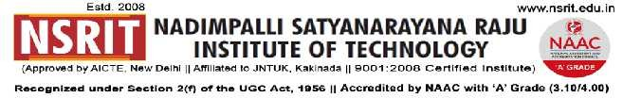
SONTYAM, ANANDAPURAM, Visakhapatnam-531173
NSRIT /CIRCULAR/2019-20/108 Date: 09-01-2020
CIRCULAR

- “Sankranthi Samskruthi” Celebrations will be held on 11-01-2020 (Second Saturday).
- Sankranthi holidays are declared from 13th January to 19th January 2020.
- The college will reopen on 20.01.2020 (Monday)

Principal
Copy to
- Secretary: for kind information.
- Correspondent: for kind information.
- A.O: for information
- All HODs–CE/EEE/ME/ECE/CSE/S&H/MBA/DIP/OIE/LIB/PD/ACC/HOSTEL(B/G): for information and circulate among all the students.

CE | EEE | ME | ECE | CSE | S&H | MBA | DIP | OIE | LIB | PD

Class Rooms
Section | Staff | Student | Section | Staff | Student | Section | Staff | Student | Section | Staff | Student
I CSE-A |  |  | II CE |  |  | II ME-A |  |  | II ECE
I CSE-B |  |  | III CE |  |  | II ME-B |  |  | III ECE
I ECE-A |  |  | IV CE |  |  | III ME-A |  |  | IV ECE
I ECE-B |  |  | II EEE |  |  | III ME-B |  |  | II CSE
I CE+EEE |  |  | III EEE |  |  | IV ME-A |  |  | III CSE
I ME |  |  | IV EEE |  |  | IV ME-B |  |  | IV CSE
I DME-A |  |  | III DME-A |  |  | I DEEE |  |  | I MBA-A
I DME-B |  |  | III DME-B |  |  | II DEEE |  |  | I MBA-B
II DME-A |  |  |  |  |  | III DEEE |  |  | II MBA
II DME-B

-----------------------------------------------------------------------------------------------------------------------------
Copy to: CTO : With a request to not to operate buses from 12-01-2020 to 19.01.2020. All the services may be operated as usual from 20-01-2020.
-----------------------------------------------------------------------------------------------------------------------------

