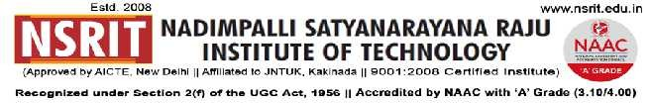
SONTYAM, ANANDAPURAM, Visakhapatnam-531173
NSRIT /CIRCULAR/2019-20/109 Date: 09-01-2020
CIRCULAR

- “Sankranthi Samskruthi” Celebrations will be held on 11-01-2020 (Second Saturday).
- Sankranthi holidays are declared from 13th January to 19th January 2020 for all staff members.
- The College will be working on 12.01.2020 (Sunday) for all staff members from 9.00 AM to 04.30 PM to discuss on Academic, Results and Autonomous issues.
- The college will reopen on 20.01.2020 (Monday).
The transport arrangement on 12.01.2020(Sunday), as given below has been made for all staff members.
Principal
Copy to
- Secretary: for kind information.
- Correspondent: for kind information.
- A.O: for information
- All HODs–CE/EEE/ME/ECE/CSE/S&H/MBA/DIP/OIE/LIB/PD/ACC/HOSTEL(B/G): for information.

CE | EEE | ME | ECE | CSE | S&H | MBA | DIP | OIE | LIB | PD

The buses schedule and route details exclusively for staff members are as follows:

Route – 1  C-Bus | Start Time : 07.30 AM – Kurmannapalem – Old Gajuwaka - NAD – Gopalapatnam – Gosala – Simhapuri Colony – Vepagunta – Pendurthi - NSRIT (Incharge : P.Gurunath - 9885991996).
Route – 2  H-Bus | Start Time : 07.30 AM – R&B - Akkayyapalem – Kancharapalem – Gurudwara – Satyam Jn., - Maddilapalem – Dairy Form – Yendada – Madhurawada – Anandapuram – NSRIT (Incharge : K.Ram Prasad – 7569323977).

-----------------------------------------------------------------------------------------------------------------------------
Copy to: CTO : with a request to not to operate buses from 12-01-2020 to 19.01.2020. All the services may be operated as usual from 20-01-2020.
-----------------------------------------------------------------------------------------------------------------------------

