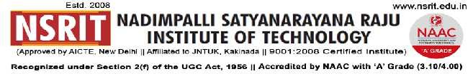
SONTYAM, ANANDAPURAM, Visakhapatnam-531173

NSRIT/CIRCULAR/2019-20/111 Date : 07.01.2020

CIRCULAR

In view of Sankranthi declared for college from 12.01.2020 (Sunday) to 19.01.2020 (Sunday) the hostels & canteen will remain closed as given below :

Hostels of both girls & boys will remain closed from 12.1.2020 (Sunday) to 18.01.2020 (Saturday) and reopen on 19.1.2020 (Sunday).

College canteen will also remain closed from 12.1.2020 (Sunday) to 18.1.2020 (Saturday) and reopen in the morning of 19.1.2020 (Sunday).

PRINCIPAL

Copy to

- Secretary: for kind information.
- Correspondent: for kind information.
- A.O: for information
- Chief Warden (Boys) : for information and circulate among all the hostlers.
- Chief Warden (Girls) : for information and circulate among all the hostlers.
- Canteen Contractor : for information.

Chief Warden(Boys) | Chief Warden (Girls) | Canteen Contractor

