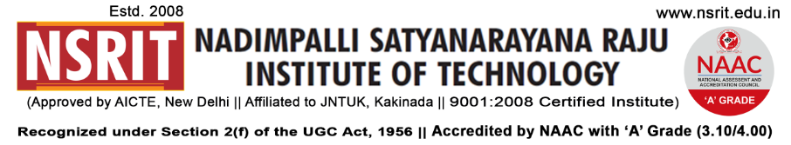
SONTYAM, ANANDAPURAM, Visakhapatnam-531173
NSRIT /CIRCULAR/2019-20/112 Date: 11-01-2020

CIRCULAR

The college observes holiday tomorrow 12-01-2020 (Sunday), college will work 19-01-2020 (Sunday) for all the staff members.

PRINCIPAL
Copy to
- Secretary: for kind information.
- Correspondent: for kind information.
- A.O for information
- All HODs – CE/EEE/ME/ECE/CSE/S&H/MBA/DIP/OIE/LIB/PD: for information.

CE | EEE | ME | ECE | CSE | S&H | MBA | DIP | OIE | LIB | PD

