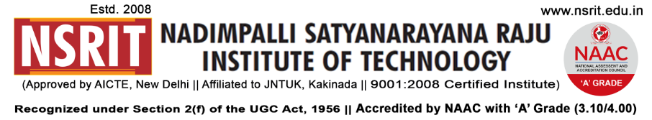
SONTYAM, ANANDAPURAM, Visakhapatnam-531173
NSRIT/CIR/Staff/2019-20/114 Date: 22.01.2020

CIRCULAR

The 71st Republic Day will be celebrated at NSRIT Campus on 26th January, 2020 (Sunday). All the staff members & students are requested to attend the Flag Hoisting Ceremony at 9.00 AM without fail.

As per the tradition of NSRIT a boy topper will hoist the National Flag on Republic Day. Mr. GANAPATHI RAJU VAMSI KRISHNA (17NU5A0320) of B.Tech IV-ME Branch stood first with 80.54 % upto 4-1 in JNTUK results among all the boy students as on date.

Mr. GANAPATHI RAJU VAMSI KRISHNA will hoist the National Flag on 26-01-2020 (Sunday).

The transport arrangement on 26.01.2020 (Sunday), as given below has been made for all staff & Students.
“WISH YOU ALL A VERY HAPPY REPUBLIC DAY”

PRINCIPAL
Copy to:
- Secretary : for kind information
- All HODs – CE//EEE//ME//ECE//CSE//S&H//MBA/DIP/LIB/PD/OIE- for information and to circulate among all the students.
- A.O: for information

CE | EEE | ME | ECE | CSE | S&H | MBA | DIP | OIE | LIB | PD

The buses schedule and route details exclusively for staff & students are as follows:
Route – 1  - Bus | Start Time : 07.30 AM – Old Gajuwaka – BHPV - NAD – Gopalapatnam – Vepagunta – Sujatha Nagar – Pendurthi - NSRIT (Incharge : P.Gurunath - 9885991996).
Route – 2  - Bus | Start Time : 07.30 AM – R&B - Akkayyapalem – Kancharapalem – Gurudwara – Satyam Jn., - Maddilapalem – Dairy Form – Yendada – Madhurawada – Anandapuram – NSRIT (Incharge : K.Ram Prasad – 7569323977).

Class Rooms
Section | Staff | Student | Section | Staff | Student | Section | Staff | Student | Section | Staff | Student
I CSE-A |  |  | II CE |  |  | II ME-A |  |  | II ECE-A
I CSE-B |  |  | III CE |  |  | II ME-B |  |  | II ECE-B
I ECE-A |  |  | IV CE |  |  | III ME-A |  |  | III ECE
I ECE-B |  |  | II EEE |  |  | III ME-B |  |  | IV ECE
I CE+EEE |  |  | III EEE |  |  | IV ME-A |  |  | II CSE-A
I ME |  |  | IV EEE |  |  | IV ME-B |  |  | II CSE-B
I DME-A |  |  | III DME-A |  |  | I DEEE |  |  | III CSE
I DME-B |  |  | III DME-B |  |  | II DEEE |  |  | IV CSE
II DME-A |  |  |  |  |  | III DEEE |  |  | I MBA-A
II DME-B |  |  |  |  |  |  |  |  | I MBA-B
 |  |  |  |  |  |  |  |  | II MBA

