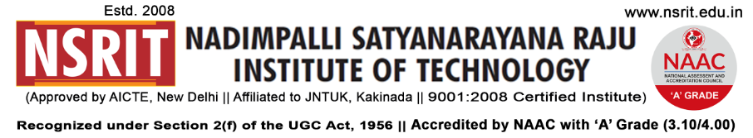
SONTYAM, ANANDAPURAM, Visakhapatnam-531173
NSRIT /CIRCULAR/2019-20/116 Date: 31-01-2020

CIRCULAR

The team Design Space is organizing an event “LOOPOUT - execute your ideas for implementation” in collaboration with NRDC & MSME to pull out best innovative & startup ideas from the students. The best innovative ideas will be applied in MSME for sponsorship and in NRDC for patent. The HODs have to encourage your students to take participate in this event

PRINCIPAL
Copy to
- Secretary: for kind information.
- A.O for information
- All HODs – CE/EEE/ME/ECE/CSE/S&H/MBA/DIP/OIE/LIB/PD: for information and circulation among all the students.

CE | EEE | ME | ECE | CSE | S&H | MBA

