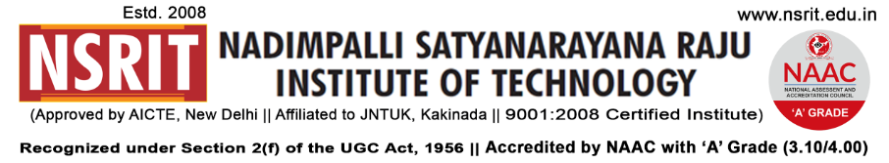
SONTYAM, ANANDAPURAM, Visakhapatnam-531173

NSRIT/CIRCULAR/2019-20/117 Date: 01.02.2020

Sub:- In-charge Principal – Regarding

***

Mr. G.Rajasekharam, HOD-CSE will be In-charge Principal and look after the routine duties of the Principal, during my absence from 03-02-2020 to 05-02-2020.

Principal

Copy to:
- Secretary : for kind information
- All HODs – CE/EEE/ME/ECE/CSE/S&H/MBA/DIP: for information.
- A.O: for information.

CE | EEE | ME | ECE | CSE | S&H | DIP

