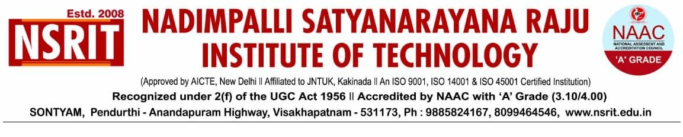SONTYAM, ANANDAPURAM, Visakhapatnam-531173
NSRIT/CIR/Staff/2019-20/119 Date: 04.02.2019

CIRCULAR

The Management, Principal and Staff of Nadimpalli Satyanarayana Raju Institute of Technology (NSRIT) Congratulate Dr. B.Chinna Rao M.Tech., Ph.D., Professor, Department of Electronics & Communication Engineering for receiving Ph.D Degree from JNTUH.

PRINCIPAL

Copy to
- Secretary: for kind information.
- A.O for information
- All HODs – CE/EEE/ME/ECE/CSE/S&H/MBA/DIP/OIE/LIB/PD: for information

CE | EEE | ME | ECE | CSE | S&H | MBA | DIP | OIE | LIB | PD

