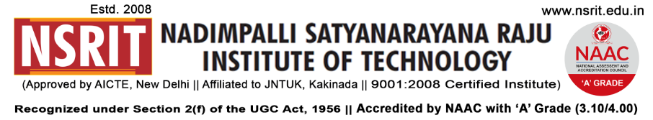
SONTYAM, ANANDAPURAM, Visakhapatnam-531173
NSRIT/CIR/Staff/2018-19/15 Date: 13.08.2018

CIRCULAR

It is to be informed to all the Diploma students that we are organizing internal Volley Ball Tournament for Boys and Throw Ball for Girls, those who are interested can contact Mr.P.Gurunath, Physical Director on or before 16.08.2018.
Registration Fee Rs.300/- per team
Actual schedule will be informed after the registration process.

Note : Once team list is submitted will not be modified
Until tournament concludes

PRINCIPAL

Copy to:

- Secretary – for kind information
- Correspondent – for kind information
- All HODs – CE/EEE/ME/ECE/CSE/S&H/MBA/Diploma: for information

