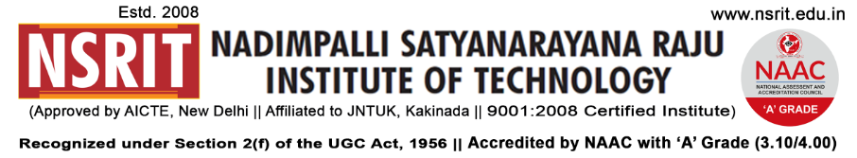SONTYAM, ANANDAPURAM, Visakhapatnam-531173

NSRIT /CIR/staff/2018-19/15 Date: 14-08-2018

**CIRCULAR**

**Independence Day Celebrations – 2018**

**The 72nd Independence Day** will be celebrated at NSRIT Campus on **15th August, 2018 (Wednesday).** All the staff members & students are requested to attend for the **Flag Hoisting Ceremony at 9.00 AM** without fail.

The buses schedule and route details are as follows.

|  |  |
| --- | --- |
| **Route – 1** | **Start Time : 7.30 AM** –– Dabagarden, LIC, Gurudwara, Satyam Jn., Eenadu, Seethammadhara, Isukathota, Venkojipalem, Yendada, Madhurawada, Anandapuram – NSRIT Campus.  **Contact : D.Sravani – Asst Prof (English) - 9000765962** |
| **Route – 2** | **Start Time : 7.30 AM** – Kurmannapalem, Srinagar, Old Gajuwaka, Sheelanagar, NAD, Gopalapatnam Bunk, Gosala, Simhachalam - NSRIT Campus.  **Contact : P.Gurunath – Physical Director – 9885991996**. |
| **Route – 3** | **Start Time : 7.30 AM** – Akkayyapalem, Thatichetlapalem, Kancharapalem, R&B, NAD, Gopalapatnam Bunk, Naidu Thota, Vepagunta, Sujatha Nagar, Pendurthi – NSRIT Campus.  **Contact : K.Manoj Kumar – Asst Prof (S&H) – 9542277896**. |

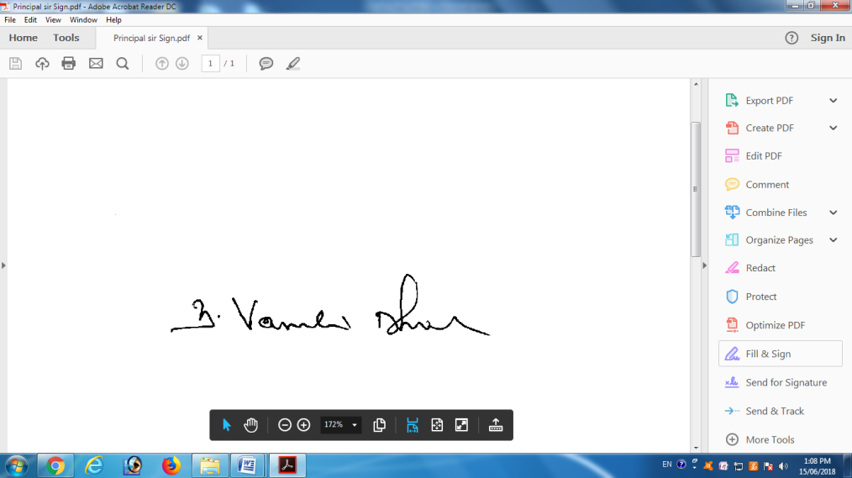

**PRINCIPAL**

To

1. Secretary**:** for kind information.
2. Correspondent: for kind information.
3. A.O for information and necessary action.
4. HOD **–** S&H/MBA/CIVIL/EEE/ME/ECE/CSE/OIE/DIP – for information and circulation to all students.

---------------------------------------------------------------------------------------------------------------------

Copy to: Transport In-charge: He is requested **not to operate** remaining busses on 15-8-2018. **All the services may be operated as usual from 16-8-2018.**

**---------------------------------------------------------------------------------------------------------------------**