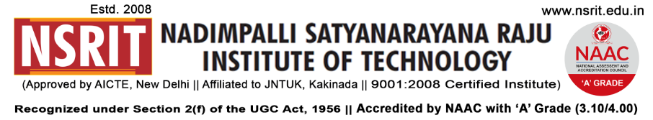
SONTYAM, ANANDAPURAM, Visakhapatnam-531173
NSRIT/CIR/staff/2017-18/17 Date: 21.08.2018
CIRCULAR

The Institute will observe holiday on 22-08-2018 (Wednesday) on account of “BAKRID (EID-UL-AZHA) ”.

PRINCIPAL

Copy to
- Secretary: for kind information.
- Correspondent: for kind information.
- A.O for information and necessary action.
- HOD – S&H/MBA/CIVIL/EEE/ME/ECE/CSE/OIE/DIP – for information and circulation to all students.

---------------------------------------------------------------------------------------------------------------------
Copy to: Transport In-charge: He is requested not to operate busses on 22-08-2018. All the services may be operated as usual from 23-08-2018.
---------------------------------------------------------------------------------------------------------------------

***

