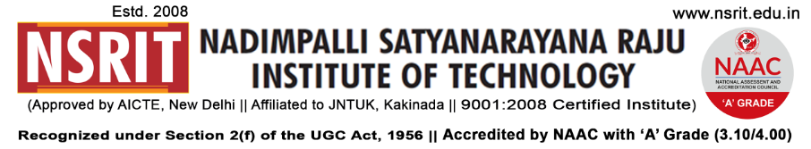
SONTYAM, ANANDAPURAM, Visakhapatnam-531173
NSRIT/CIR/staff/2017-18/18 Date: 22.08.2018

CIRCULAR

All the HODs are hereby requested to send the details (Photos and brief note) of any events conducted in the departments to Mr.V.Rama Rao, Asst. Professor (Email : nsrit.web@gmail.com), Send a copy to principal.nsrit@gmail.com.

PRINCIPAL

Copy to
- Secretary: for kind information.
- Correspondent: for kind information.
- A.O for information and necessary action.
- HOD – S&H/MBA/CIVIL/EEE/ME/ECE/CSE/OIE/DIP – for information and circulation to all students.

