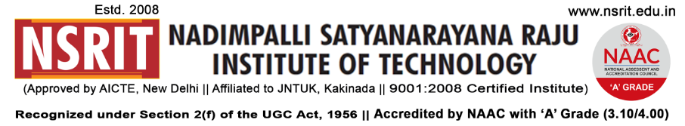
SONTYAM, ANANDAPURAM, Visakhapatnam-531173
NSRIT/CIR/staff/2018-19/19 Date: 23.08.2018

CIRCULAR

On account of “VARALAXMI VRATAM” all the Female Staff members can avail permission upto 10.30 am tomorrow dt. 24.08.2018 with necessary work adjustments.

PRINCIPAL

Copy to
- Secretary: for kind information.
- Correspondent: for kind information.
- A.O for information and necessary action.
- HOD – S&H/MBA/CIVIL/EEE/ME/ECE/CSE/OIE/DIP/Lib – for information.

