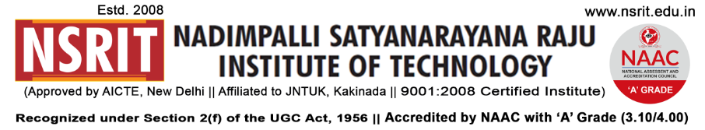
SONTYAM, ANANDAPURAM, Visakhapatnam-531173
NSRIT/CIR/Staff/2018-19/22 Date: 28.08.2018

CIRCULAR

All the faculty and students are hereby informed that, in view of “NATIONAL SPORTS DAY” celebrations are being conducted in memory of India`s legendry hockey player “Major Dhyan Chand” at Seminar Hall, Block-I on 29.8.2018 by 10.00 am. All are requested to make it convenient to attend the programme.

On this occasion NCL “NSRIT Cricket League” brochure launching and prize distribution for Diploma Volley Ball Winners will be done.
Special Invitees :
1) Dr.N.Prasada Raju (Secretary)
2) Sri N.Kanaka Raju (Treasurer)

PRINCIPAL

Copy to:

- Secretary – for kind information
- Correspondent – for kind information
- All HODs – CE/EEE/ME/ECE/CSE/S&H/MBA/Diploma: for information and circulate among all the students.

