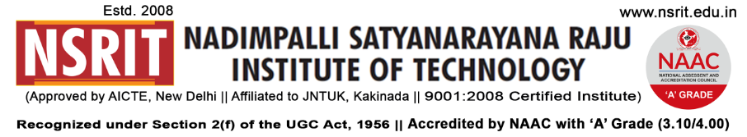
SONTYAM, ANANDAPURAM, Visakhapatnam-531173
NSRIT/CIR/Staff/2018-19/24 Date: 30.08.2018

ON CAMPUS DRIVE CIRCULAR

It’s here by informed that all the IV B. Tech (ECE&EEE), III Diploma (EEE) & II MBA (HR, Finance & Marketing) students are requested to attend themselves to the On Campus Drive on 31st Aug 2018 of A2Z Laundry Services, Bangalore.
Job description – (1) B. Tech
Nature of Job : Services & maintenance Engineers
Branch : ECE & EEE
Percentage : 60% without backlogs
Salary : 1.6 to 2.64 LPA

Job description – (2) Diploma
Nature of Job : Services & maintenance Executive
Branch : EEE
Percentage : 60% without backlogs
Salary : 1.5 to 2.16 LPA
Gross Salary : 5.1 to 5.76

Job description – (3) MBA
Nature of Job : Marketing Dept
Branch : MBA (Marketing/Finance)
Percentage : 60% without backlogs
Salary : 1.8 to 3.0 LPA
Gross salary : 3.6 LPA

Job description – (4) MBA
Nature of Job : Accounts & HR Executive
Branch : MBA (Finance/HR)
Percentage : 60% without backlogs
Salary : 1.5 to 2.4 LPA
Gross salary : 5.1 to 6 LPA
PRINCIPAL
Copy to:

- Secretary – for kind information
- Correspondent – for kind information
- All HODs – CE/EEE/ME/ECE/CSE/S&H/MBA/Diploma: for information and circulate
among all the students.

