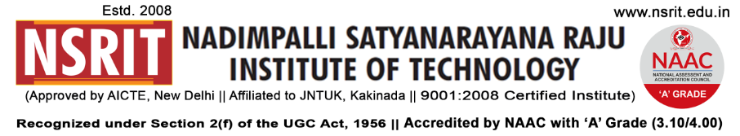
SONTYAM, ANANDAPURAM, Visakhapatnam-531173
NSRIT/CIR/Staff/2018-19/25 Date: 01.09.2018

CIRCULAR

This is to inform all staff & students that “NSRIT – Helping Hands” has been constituted as a social responsibility initiative from NSRIT and approved by the Principal and all HODs to initiate the habit of helping needy people among the students in the situations like :

Natural Calamities/disasters
Food & books for the very poor children
Spending some time for tutions to the orphanage children
Other service/charity activities in collaboration with Akshaya Patra Foundation, whenever necessary.

* Any fund raising activity shall be started by taking prior approval from Principal.

Faculty Coordinators : 1) N.Sai Varma, Correspondent
2) B.Srinivas, Assoc Prof & NSS Program In-charge
3) P.Murali Krishna, Assoc Prof & HOD, Mech
4) G.Raja Sekharam, Assoc Prof & HOD, CSE
5) A.Madhavi Latha, Sr.Asst Prof, MBA

Student Coordinators : 1) S.Rahul, Mech
2) P.Haritha, ECE
3) P.Himaja, ECE
4) Ch.Bhaskar, MBA
5) Ch.Raghunath, EEE
6) Akesh Varma, CE

PRINCIPAL

Copy to:

- Secretary – for kind information
- Correspondent – for kind information
- All HODs – CE/EEE/ME/ECE/CSE/S&H/MBA/Diploma: for information and circulate
among all the students.

