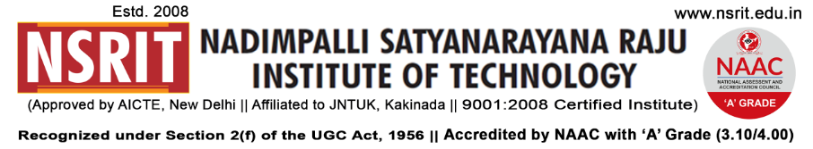
SONTYAM, ANANDAPURAM, Visakhapatnam-531173
NSRIT/CIR/staff/2018-19/26 Date: 01.09.2018
CIRCULAR

The Institute will observe holiday on 03-09-2018 (Monday) on account of “SRI KRISHNA ASTAMI ”.

PRINCIPAL

Copy to
- Secretary: for kind information.
- Correspondent: for kind information.
- A.O for information
- HOD – S&H/MBA/CIVIL/EEE/ME/ECE/CSE/OIE/DIP/PD/Lib/Accounts/Transport –

for information and circulation to all students

