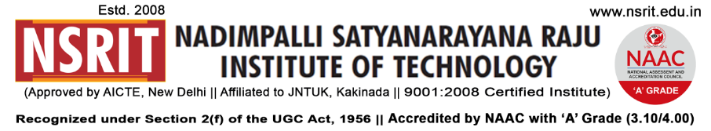
SONTYAM, ANANDAPURAM, Visakhapatnam-531173
NSRIT /CIR/staff/2018-19/30 Date: 06-09-2018

CIRCULAR

Here by inform you that NSRIT is going to inaugurate the “ CREATIVE CLUBS” for students on 06-09-2018, Thursday After noon from 2.00 to 4.30 PM. It is here by instructed that all the members of respective creative clubs are supposed to gather at their venue by sharp 2.00 P.M. The details of the venue are as follows :

Sno | Name of the club | Venue | Co ordinator | Inaugural  time
1 | Multimedia Club | INC LAB Block-3 | Dr.k.Madhavi (CSE) | 2.00 PM
2 | Music Club | Seminar Hall Block-3 | MVS.Roja Ramani(ECE) | 2.15 PM
3 | Photography Club | Room 308 Block-2 | A.Matha Prasad (CE) | 2.30 PM
4 | Movie Making Club | Seminar Hall Block-2 | S.Sanyasi Rao (MECH) | 2.45 PM
5 | Literary Club | English Lab Block-1 | BK.Maheswar Rao( S&H) | 3.00 PM
6 | Painting Club | Drawing Hall Block-1 | M.Sreedevi ( EEE) | 3.15 PM
7 | Dance Club | Seminar Hall Block-1 | M.Prashanthi | 4.00 PM

All the HOD s are here by requested to send the concerned students to their respective venues on time helping us in maintaining harmony in the campus.

Seeking all your co operation in making this event a grand success

PRINCIPAL
Copy to
- Secretary: for kind information.
- Correspondent: for kind information.
- A.O for information
- HOD – S&H/MBA/CIVIL/EEE/ME/ECE/CSE/DIP – for information and circulate among all the
Students.

