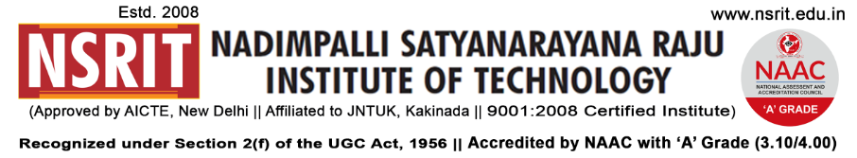
SONTYAM, ANANDAPURAM, Visakhapatnam-531173
NSRIT /CIR/staff/2018-19/35 Date: 14-09-2018

CIRCULAR

Here by inform you that NSRIT is going to inaugurate the “ TECHNICAL CLUBS” for students on 15.09-2018, Saturday after noon from 1.00 PM to 2.30 PM. It is here by informed that all the members of respective Technical Clubs are supposed to gather at their venue by sharp 1.00 P.M. The details of the venue are as follows :

Sno | Name of the club | Venue | Co ordinator | Inaugural  time
1 | Coding Club | CP Lab – Block-I | J.Santoshi Kumari(CSE) | 1.10 pm
2 | Mobile App Club | CP Lab – Block-I | D.Aparna (CSE) | 1.10 pm
3 | Embedded Club | DC Lab – Block-I  (Room # 208) | P.Venkatesh (Dip) | 1.30 pm
4 | Robotics Club | Machine Tools Lab  Block-II | Ch.V.S.R.Krishna Murthy (ME) | 1.40 pm
5 | Business Club | Seminar Hall-3  Block-III | M.Rajesh (MBA) | 2.00 pm
6 | Maths Club | Seminar Hall-1  Block-I | P.Paripurna Chari (S&H) | 2.20 pm

All the HOD s are here by requested to send the concerned students to their respective venues on time helping us in maintaining harmony in the campus.

Seeking all your co operation in making this event a grand success

PRINCIPAL
Copy to
- Secretary: for kind information.
- Correspondent: for kind information.
- A.O for information
- HOD – S&H/MBA/CIVIL/EEE/ME/ECE/CSE/DIP – for information and circulate among all the
Students.

