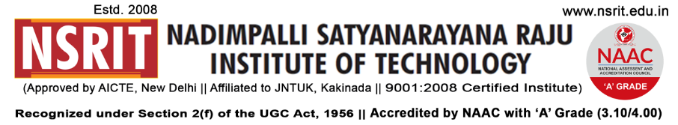
SONTYAM, ANANDAPURAM, Visakhapatnam-531173
NSRIT /CIR/staff/2018-19/36 Date: 14-09-2017

CIRCULAR

Engineers Day Celebrations – 2018

The Engineers Day Valedictory Function will be conducted on 15th Sept, 2018 (Saturday) at 2.30 pm in Block-I Seminar hall. All the staff members & student representatives are requested to attend the function.
Mr.U.Srinivasa Raju, CEO, Alykas Innovations Pvt. Ltd., IT Hill No.3, Visakhapatnam is the Guest for the function.

Principal

Copy to
- Secretary: for kind information.
- Correspondent: for kind information.
- A.O for information
- HOD – S&H/MBA/CIVIL/EEE/ME/ECE/CSE/DIP – for information and circulate among all the
Students.

