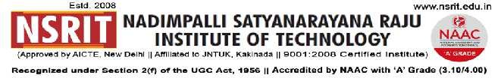
SONTYAM, ANANDAPURAM, Visakhapatnam-531173
NSRIT /CIRCULAR/2019-20/087 Date: 19-10-2019

CIRCULAR

All the HODs and Staff member are hereby informed that Transportation of NSRIT has hired 3 buses from the academic year 2019-20 apart from regular NSRIT buses and expenditure has been raised thereby incurring losses in running the buses.

So it is proposed to deduct the travelling charges from staff salary in the following slots :

1) Monthly salary less than 5000/- - 300/- per month.
2) Monthly salary 5000/- to 10000/- and less than 10000/- - 400/- per month.
3) Monthly salary above 10000/- - 900/- per month.

Principal
Copy to
- Secretary: for kind information.
- Correspondent: for kind information.
- A.O: for information
- All HODs–CE/EEE/ME/ECE/CSE/S&H/MBA/DIP: for information and circulate among all the staff members.

CE | EEE | ME | ECE | CSE | S&H | MBA | DME | DEEE | Polytechnic In-charge

